
D.C.N.S. PROGRAM CLIENT PRACTICE SHEET
IMPORTANT INFORMATION

This DCNS CPS (Client Practice Sheet) form is used to evaluate your Online Nail Program Practical Work and assist you on improving your DCNS services as you progress through your program.

Our TAOND CPS form has been specifically designed to enable our TAOND Tutors (who review each and every one of your applications and forms) to provide to you insightful and helpful feedback on ways to continuously improve your work with each additional practice service. Therefore, it is very important that you upload your forms one at a time, as you complete each individual form in order that your Tutor can catch areas of improvement as you go.

COMPLETING YOUR CPS FORM

In order to receive full marks this form must be completed in its entirety. Please use full sentences to provide explanations. This form has been designed to be filled out electronically in WORD and then UPLOADED to your Online Learning Account. Form sections for your answers will automatically expand when text is entered. If you prefer, you may also print out your forms and send them by post along with your Before and After pictures.

CPS FORM SECTIONS

This form is separated into two separate sections. The first section is Assessment & Consultation and the second section is Practice Application Notes.

The Assessment & Consultation is reserved for information with regards to your client and therefore may not necessarily change every time if you have practiced on the same client previously and this same client is receiving multiple practice applications.

The second section, Practice Application Notes, must be filled out for each practice application that you complete in order to receive full marks for your practical work.

# OF REQUIRED PRACTICAL WORK

You must submit the required number of DCNS Client Practice Sheets (CPSs) below in order to complete your DCNS Program:

- 5 D.C.N.S. Manicure Services complete with Client Assessment & Consultation forms, detailed explanation of recommended retail suggestions, and before and after service pictures.
- 5 Follow-up D.C.N.S. Manicure Services completed on the same clients within a 3-week time frame, with detailed client feedback, before and after pictures.

- 5 D.C.N.S. Pedicure Services complete with Client Assessment & Consultation forms, detailed explanation of recommended retail suggestions, and before and after service pictures.

- 5 Follow-up D.C.N.S. Pedicure Services completed on the same clients within a 3-week time frame, with detailed client feedback, before and after pictures.

If you have any questions regarding your practical work requirements, please email us at info@taond.com.

CPS FORM COMPLETION

- Incomplete CPS forms will be returned with specific comments from our TAOND Tutors on what sections need to be completed.

- Incomplete CPS forms will not be counted towards your required number of services until such time that they are fully completed and signed off by your Tutor.

- If areas on this form are not applicable for a certain application process, please note so in the corresponding section with a "N/A".

- Before and after pictures of your work and products are mandatory requirements. Therefore, you must insert product, before and after pictures in the specified section of this document. Before and After pictures must include both hands or feet (dependent on the service) and must be clear, high resolution, show proper hand placement, be well lit and in focus.

RECORD KEEPING

YOU MUST MAINTAIN A COPY OF YOUR CPS FORMS in your own records. The Academy of Nail Design will not be responsible for lost, misplaced, or improperly uploaded CPS forms, and you are required to maintain a copy for your records in all circumstances and/or in the event of misplaced mailings, technical issues or uploading issues. If you are mailing the client assessment forms, mail only copies of your CPS forms. It is your responsibility to ensure the forms are received by our office and we suggest sending by Registered Mail.

Your CPS forms MUST be signed by your practice Client. You can have them sign the printout copy that you maintain in your student files and then simply indicate “Client signature on file” where the signature line is, or you can have them sign electronically.

HOW TO REACH US

If you have any questions regarding how to properly complete this form or any other questions referring to your CPS forms, please email us at info@taond.com or call us directly by telephone at 1 (844) 998-2663 - or internationally at 1 (313) 447-0499.

For CPS submissions sent by post, please address your envelope to:

The Academy Of Nail Design
1051 2nd Avenue East Suite #227
Owen Sound, ON N4K 2H8
Canada

CLIENT ASSESSMENT & CONSULTATION FORM

CLIENT CONTACT INFORMATION
*If your client doesn't want to provide full address information you MUST at least provide their City & State or Province
Name:
Address:
City: |  |  | Province/State:
Work Phone #: |  |  | Home Phone #:
Best Time To Reach:
Emergency Contact Name and Number:
Email Address:
CLIENT SERVICES AND LIFESTYLE BACKGROUND
Previous Services
What type of nail service(s) have you had in the past?
(Mark in the box with an “X” all those that apply)
Manicures: |  | YES |  | NO
Spa Manicure: |  | YES |  | NO
Pedicures: |  | YES |  | NO
Spa Pedicure: |  | YES |  | NO
Acrylic Enhancements: |  | YES |  | NO
UV Gel Enhancements: |  | YES |  | NO
Others (please specify):
Were you satisfied with the services: |  | YES |  | NO
If you answered “NO” to any of the above, please explain “why?”.
LIFESTYLE
In your line of work do you frequently wash your hands?
Do you wear rubber gloves when doing housework or gardening?
Do you spend a great deal of time caring for your own nails?
Are you generally hard on your nails?
Do you purchase retails items for nails, hands, and feet care?
Please list any brands in the past that you enjoyed.
MEDICAL HISTORY
Do you have (or have had) any of the following:
(Mark in the box with an “X” all those that apply)
Arthritis: |  | YES |  | NO
Cancer: |  | YES |  | NO
Diabetes: |  | YES |  | NO
Heart Problems: |  | YES |  | NO
High Blood Pressure: |  | YES |  | NO
Stroke: |  | YES |  | NO
Others (please list):
If you answered “YES” to any of the above or identified any medical issues under 'other' please list any current medications:
Are there any other medical conditions, medications or allergies that that we should be aware of including nut, essential oil, latex or other food allergies?

OBSERVATION OF HANDS
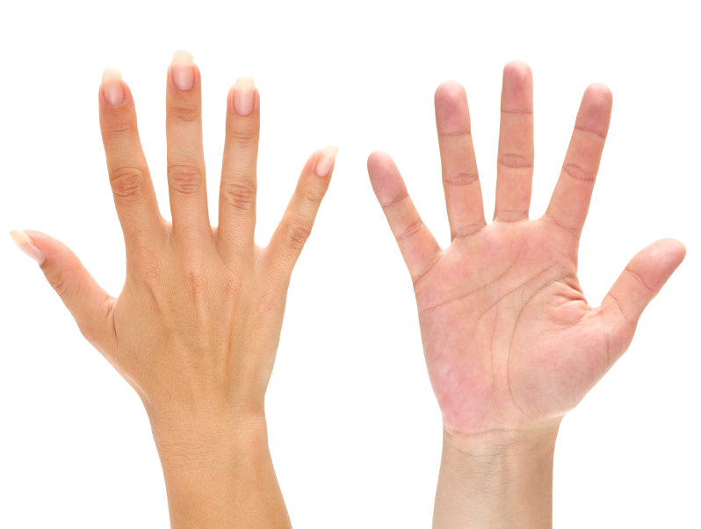
Right Hand Notes

What type of nails does your client have?
What type of skin does your client have?
Are there any specific evidence of issues that contravenes the "GOLDEN RULE"?

Left Hand Notes

What type of nails does your client have?
What type of skin does your client have?
Are there any specific evidence of issues that contravenes the "GOLDEN RULE"?

RECOMMENDED D.C.N.S. SERVICE

Recommended service for hands including specific products
Why?

Recommended Home Care for the hands
Why?

Date:
Client Signature:
D.C.N.S. Signature:

FOLLOW-UP SERVICE NOTES
Date:
Service Performed:
Client Comments:

D.C.N.S. Comments:
Home Care Comments:

Date:
Service Performed:
Client Comments:

D.C.N.S. Comments:
Home Care Comments:

Date:
Service Performed:
Client Comments:

D.C.N.S. Comments:
Home Care Comments:

D.C.N.S. APPLICATION DESCRIPTION

Client Name:

List the application you did for this Sheet:
Set up check list – list ALL the products and implements you used for this application process:

Type and Brand name of the products you used:

Explanation of your D.C.N.S. decontamination process before and after service:
Client comments and feedback:

TIMING OF SERVICE – Please fill in your Start time, including assessment, set up and prep time and Finish time including clean up and proper decontamination time.
Set Up Time:
Service Start Time:
Service Finish Time:
TOTAL DCNS SERVICE TIME:

Additional Student Comments:

Insert your BEFORE picture here
NOTE: ‘Before’ picture must include both hands and must be clear, high resolution, show proper hand placement, be well lit and in focus.

Insert your AFTER picture here
NOTE: ‘After’ picture must include both hands and must be clear, high resolution, show proper hand placement, be well lit and in focus.

