Business Plan Sample Outline______________

Please be advised this is a very simple business plan layout. If your business or financial institution require you to expand on the basics laid out here, we would suggest you obtain a more detailed business plan template to follow.
We have included this sample to give you a solid start about thinking and planning out your business.

Name of the business: _______________________________
Business overview:
(Use this section to describe your business)

The industry and its nature:

TAOND Mobile Nail Professional e-Guide © 2025

Government regulations:

Target Market:

Market trends:

Products and services you'll be providing:

TAOND Mobile Nail Professional e-Guide © 2025

Pricing strategy:

Competitors:

Competitive advantages:

TAOND Mobile Nail Professional e-Guide © 2025

Risk factors:

Suppliers:

TAOND Mobile Nail Professional e-Guide © 2025

Sales & Marketing Plan
(Use this section to describe the following)
Who your target market is:

Your marketing strategy:

Advertising and promotions:

TAOND Mobile Nail Professional e-Guide © 2025

Executive summary
(Use this section to give a brief description of your business, any financing that may be required and any additional information that may further describe your business.)

TAOND Mobile Nail Professional e-Guide © 2025

Operating Plan
(Use this section to describe your business requirements; equipment, leasing information etc.)

TAOND Mobile Nail Professional e-Guide © 2025

Financial Documents
(Use this section to attach any requested financial documents require for obtaining financing.)

TAOND Mobile Nail Professional e-Guide © 2025

Mission Statement_______________________

TAOND Mobile Nail Professional e-Guide © 2025

Professional Advice Check List______________


Business Banking Agent Name of institution:
Agent's name:
Contact info:


Accountant
Name of institution:
Agent's name:
Contact info:

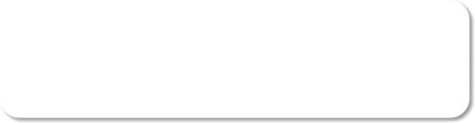
Lawyer
Name of institution:
Agent's name:
Contact info:

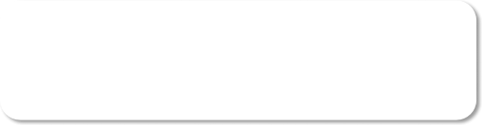
Insurance Agent
Name of institution:
Agent's name:
Contact info:

TAOND Mobile Nail Professional e-Guide © 2025

Product and Accessory Checklist_____________

 |  | Quantity | Product Name and re-order Info
 | Professional Travel Case
Manicure & Pedicure Line
 | Hand and foot cream
 | Cuticle oil
 | Hand and foot Scrub
 | Hydrating mask
 | Hand and foot soak
 | Hand soap
 | Fiber glass kit
 | Acrylic Kit
 | UV Gel kit
Polish
 | Polish line
 | Base coat and top coat
 | Polish holder
 | Polish Corrector sticks
Accessories
 | Electric mitts
 | Electric booties
 | Comfort wedge
 | Cuticle Nippers
 | Cuticle Pushers
 | Nail Clippers
 | Disinfecting Tray
 | Pedicure Slippers
 | Toe Separators

TAOND Mobile Nail Professional e-Guide © 2025

Pedicure Foot File & Replacement Pads
Scrub brushes
Manicure Bowl
Plastic Liners
Birchwood sticks
Lint-Free Towels
Lint-Free Nail Wipes
Acetone and non-acetone pump
100/180 grit files
White Block Buffers
Gold Block buffers
3-Way buffers
Glass files
Stainless Steel pedicure bowl
Terry cloth towels
Paper towels
Decontamination Products
Surface disinfectant
Chemical sterilant
Implement wash

TAOND Mobile Nail Professional e-Guide © 2025

Cleaning Log and Decontamination Protocols__

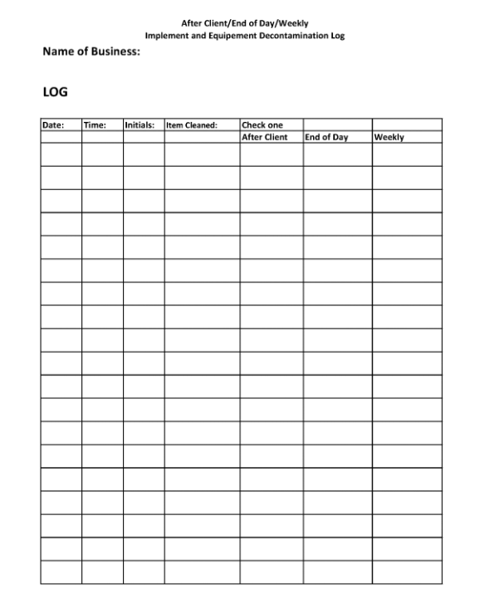

TAOND Mobile Nail Professional e-Guide © 2025

Client Assessment Sheet Sample_____________

CONTACT INFORMATION
Name:

Address: Work Phone #: _________________________________ Home Phone #: Best Time to Reach:

CLIENT SERVICE AND LIFESTYLE BACKGROUND What types of nail services have you had in the past?
Yes No

Manicures ____
____

Pedicures
Acrylic Enhancements
___
___
___
___

Fiber Glass Enhancements ___
___

Gel Enhancements
___
___

Any other please list

Were you satisfied with the services? (Yes or No) __________________________ If NO please explain why: __________________________________________
_____________________________________________________________________________________

In your line of work do you frequently wash your hands? (Yes/No) _______________ Do you wear rubber gloves when doing housework or gardening? (Yes/No) _________ Do you spend a great deal of time caring for your own nails? (Yes/No) ____________ Are you generally hard on your hands? (Yes/No) ___________________________

Please list any retail items you have purchased in the past that you enjoyed ____________________________________________________________ ____________________________________________________________

MEDICAL HISTORY
Do you have/or have you had?:

If YES, please list any current medications

YES Arthritis ___
NO
___

_____________________________

Cancer Diabetes
Heart Problems
___
___
___
___
___
___
_____________________________ _____________________________ _____________________________

High Blood Pressure ___ Stroke ___
___
___
_____________________________ _____________________________

Are there any other medical conditions, medications or allergies that we should be aware of?

OBSERVATION
Name:

Observation of skin and nails (hands)

_____________________________________________________________________________________
_____________________________________________________________________________________
_____________________________________________________________________________________

(feet)
_______________

Recommended service for hands Why:
Recommended service for feet Why:

_____________ Date:

_______________________ Nail Professional signature
______________________ Client signature

RECORD OF SERVICE

Date | Service Preformed | Comments | Retail Recommended/Sold

TAOND Mobile Nail Professional e-Guide © 2025

