

CLIENT PRACTICE SHEET FORM
IMPORTANT INFORMATION

This TAOND CPS (Client Practice Sheet) form is used to evaluate your Online Nail Program Practical Work and assist you on improving your applications as you progress through your program.

Our TAOND CPS form has been specifically designed to enable our TAOND Tutors (who review each and every one of your applications and forms) to provide to you insightful and helpful feedback on ways to continuously improve your work with each additional practice service. Therefore, it is very important that you upload your forms one at a time, as you complete each individual form in order that your Tutor can catch areas of improvement as you go.

COMPLETING YOUR CPS FORM

In order to receive full marks this form must be completed in its entirety. Please use full sentences to provide explanations. This form has been designed to be fill out electronically in WORD and then UPLOADED to your Online Learning Account. Form sections for your answers will automatically expand when text is entered.

CPS FORM SECTIONS

This form is separated into two separate sections. The first section is Assessment & Consultation, and the second section is Practice Application Notes.

The Assessment & Consultation is reserved for information with regards to your client and therefore may not necessarily change every time if you have practiced on the same client previously and this same client is receiving multiple practice applications.

The second section, Practice Application Notes, must be filled out for each practice application that you complete in order to receive full marks for your practical work.

# OF REQUIRED PRACTICAL WORK

You must submit the required number of Client Practice Sheets (CPSs) specific to the area in which you live, which has been outlined on the REQUIRED PRACTICALS BY AREA file within your Program found in Module 1 or in Practical Modules 6-10.

If you are uncertain as to how many CPS forms you are required to complete please email us at info@taond.com for confirmation.
CPS FORM COMPLETION

- Incomplete CPS forms will be returned with specific comments from our TAOND Tutors on what sections need to be completed.

- Incomplete CPS forms will not be counted towards your required number of hours until such time that they are fully completed and signed off by your Tutor.

- If areas on this form are not applicable for a certain application process, please note so in the corresponding section with a "N/A".

- Before and after pictures of your work and products are mandatory requirements. Therefore, you must insert product, before and after pictures in the specified section of this document. Before and After pictures must include both hands or feet (dependent on the service) and must clear, show proper hand placement, be well lit and in focus.

For your convenience we have upload a SAMPLE CPS form to your LMS area that you can refer to as a guideline for what a completed form resembles.

RULES ON THE USE OF A NAIL TRAINER HAND AND/OR SELF APPLICATION

As you know we do allow for 75% of your Required Practical work to be completed on either yourself or a nail trainer or silicon hand. Nail Trainers and silicon hands are only accepted for enhancement modules 8,9 & 10 and not for Natural Nail Care Modules 6 & 7 since you can’t properly perform a natural nail care service on a nail trainer or silicon hand.

If using the nail trainer or silicon hand, please specify in the form. Note that Before and After pictures are required for the nail trainer/silicon hand also. If Using a Nail Trainer or silicon hand, then you must complete 10 Nails – either two sets of Nail Trainer nails or your silicon hands twice.

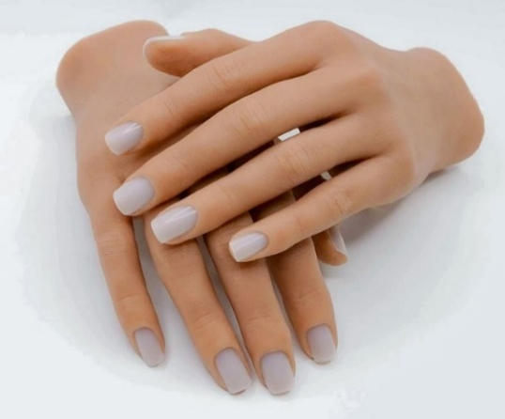

If you are performing a service on yourself then BOTH hands must be completed and shown in your Before and After pictures.

IMPROVING YOUR PRACTICAL APPLICATIONS

PLEASE ALSO NOTE in your Feedback for your CPS FORMS we will be referring you often to the TAOND Student Resource Centre.



Please be sure you check out all our videos in there, but specifically the ones we note in your feedback that will assist you in improving your work. We have recommended these for your benefit to help you improve your work on an on-going basis.

RECORD KEEPING

YOU MUST MAINTAIN A COPY OF YOUR CPS FORMS in your own records. The Academy of Nail Design will not be responsible for lost, misplaced, or improperly uploaded CPS forms, and you are required to maintain a copy for your records in all circumstances and/or in the event of misplaced mailings, technical issues or uploading issues.

Your CPS forms MUST be signed by your practice Client. You can have them sign the printout copy that you maintain in your student files and then simply indicate “Client signature on file” where the signature line is, or you can have them sign electronically.

LIABILITY INSURANCE

If you are a U.S. based student, then you must also purchase the Student Liability Insurance package as directed and insert your Policy number where indicated on the form. Click HERE to sign up with Beauty Insurance Plus Insurance. Be sure to sign up as a nail school student.



USE OF E-FILES – TAOND POLICY

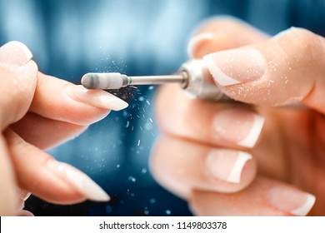

Please be advised that The Academy of Nail Design does not allow students to use an electric file during the course of their studies for their practice services UNLESS they have completed our TAOND Basic E-File Safety & Sanitation Course or a PROFESSIONAL LEVEL E-FILE TRAINING (approved by TAOND) and received a Certificate stating such training and that this Certificate has been uploaded to your student LMS record.

We also require that you advise your practice clients that you have been professionally trained to use an electric file and by allowing you to use an electric file during your practice service, your client signs off on any liability to yourself and The Academy Of Nail Design of any injury or damage that may occur due to the use of an electric file.

You must also inform your clients that they can opt not to have practice services performed with an electric file if they so choose.

HOW TO REACH US

If you have any questions regarding how to properly complete this form or any other questions referring to your CPS forms, please email us at info@taond.com or call us directly by telephone at 1 (844) 998-2663 - or internationally at 1 (425) 336-3710.

ASSESSMENT & CONSULTATION

SERVICE TIME
Please fill in your application Start time and Finish time. Then fill in your Total Time - this includes setting up, filling out the client assessment form, application process, clean up, and proper decontamination time. Ensure that you mark your total time. Total time is used to determine whether you have completed your total required program hours, whereas Application Start and Finish times will help you determine how long your actual application takes for Exam purposes.
Application Start Time:
Application Finish Time:
Total Time:
(This must also include your set up, Assessment, service & clean up time)

CLIENT CONTACT INFORMATION
*If your client doesn't want to provide full address information you MUST at least provide their City & State or Province
Name:
Address:
Work Phone #: |  |  |  | Home Phone #:
Best Time to Reach:
MEDICAL HISTORY
Do you have (or have had) any of the following?
(Mark in the box with an “X” all those that apply)
Arthritis: |  |  | YES |  | NO
Cancer: |  |  | YES |  | NO
Diabetes: |  |  | YES |  | NO
Heart Problems: |  |  | YES |  | NO
High Blood Pressure: |  |  | YES |  | NO
Stroke: |  |  | YES |  | NO
Others (please list):
If you answered “YES” to any of the above or identified any medical issues under 'others' please list any current medications:
Are there any other medical conditions, medications or allergies that I as your service provider should be aware of prior to performing your service today?
CLIENT SERVICES AND LIFESTYLE BACKGROUND
What type of nail service(s) have you had in the past?
(Mark in the box with an “X” all those that apply)
Manicure: |  |  | YES |  | NO
Pedicure: |  |  | YES |  | NO
Acrylic Enhancements: |  |  | YES |  | NO
UV Gel Enhancements: |  |  | YES |  | NO
Others (please specify):
Were you satisfied with the services? |  |  | YES |  | NO
If you answered “NO” to any of the above, please explain “why?”.
Have you ever had an allergic reaction to a nail or beauty product previously no matter how small or how long ago?
In your line of work do you frequently wash your hands?
Do you wear rubber gloves when doing housework or gardening?
Do you spend a great deal of time caring for your own nails?
Are you generally hard on your nails?
Do you purchase retail items for nails, hands, and feet care?
Please list any brands in the past that you enjoyed:
OBSERVATION OF CLIENT’S HANDS AND FEET
List your analysis and observation of the client’s hands, feet, and nails prior to service. Note all or any nail disease or disorders as well as any issues you feel necessary (i.e., Extremely dry skin). Please include a detailed observation of the condition of the client’s skin, cuticles, and nails.

For Example:
client’s skin is very dry, nails have slight ridges on them, pinky nail is bruised,
cuticles are overgrown, client has hangnails, index finger has a small cut, etc.
Hands:
(If not applicable for this service, because you’re performing a Pedicure or using a Nail Trainer, please state “not applicable”)
Feet:
(If not applicable for this service, because you’re performing a Manicure, please state “not applicable”)
Based on your observations, what service do you recommend today? Please also include a list of recommended products and/or services for future use for the client as well as any retail homecare products and care regimes for this client.
Why are you recommending today’s service, future services, and above products?

PRACTICE APPLICATION NOTES
ALL SECTIONS MUST BE COMPLETED IN FULL

List the Service Application that was performed on this client.
(i.e. Spa Manicure or Acrylic with tips etc.)
***PLEASE LIST DOWN ALL BRAND NAMES***

Products for Service: | Decontamination Products:
Implements and Files/Buffers (include grits): | Cleaning Supplies:

FYI – WE WILL ASK YOU TO INSERT A PICTURE OF YOUR LISTED MATERIALS INCLUDING SERVICE PRODUCTS AND DECONTAMINATION PRODUCTS AT THE END OF YOUR CPS FORM WITH YOUR 'BEFORE' & 'AFTER' CLIENT PICTURES

What areas during this practice service worked well for you?
(i.e. callous removal, tip application, shaping & consistency, etc.)

What areas of this service need improving? Be specific and detailed in your answer.
(i.e. cuticle maintenance, tip blending, shaping & consistency, etc.)

Explain how you plan on addressing these problem areas in order to improve your practice services going forward. Be specific and detailed in your response. 'More Practice' is not a qualified answer. We at TAOND feel that self-assessment is a vital part of your learning process, therefore, please be detailed.

Don’t forget! We have an excellent Student Resource Center where you can find a ton of helpful resources and videos

Provide a full explanation of your Decontamination Process after the service. You MUST include every protocol you implement for all aspects of your work environment including but not limited to: re-useable implements, surface areas, one time use items, pedicure basins, towels etc.
***Please specify the BRAND NAME of disinfectants, sanitizers etc.
And indicate the product RATIO for products that require mixing (i.e. Barbicide, etc.)

Manicure Bowl and/or Pedicure Basin (If applicable for the service done):

Reusable Implements:

One Time Use Items:

Surfaces:

Floors:

Towels:

Garbage:

Client Feedback Comments on today’s service:

Student Feedback Comments on today’s service:

I certify that:
- A hard copy of this Client Assessment Form will be kept on file with the original signatures and a copy of this form will be provided to the client upon their request.
- I have explained in detail to the client that they are a practice client recruited in order to fulfill my program hour requirements and that by signing this Client Assessment Form the client waives any and all liability related to today’s service, any future services, and application processes.
- All information on this form is private and confidential and will only be shared with The Academy of Nail Design for reviewing and grading purposes.
- I acknowledge that The Academy Of Nail Design does not allow students to use an electric file during the course of their studies and that if I do choose to using an electric file during my practice services that this can only happen if I completed TAOND’s E-File Course or a PROFESSIONAL LEVEL E-FILE TRAINING and received a Certificate stating such training and that this Certificate has been uploaded to my student LMS account as record. I also have advised my practice client that I have been professionally trained to use an electric file and by allowing me to use an electric file during my practice service they sign off on any liability to both myself and The Academy Of Nail Design of any injury or damage that may occur due to the use of an electric file. I have also informed my client that they can opt not to have practice services performed with an electric file if they so choose.
- I, personally, have completed this application and practice service in its entirety and that the information contained herein is accurate to the best of my knowledge.

Date |  | Date

 | Student Name |  | Client Signature
*REQUIRED FOR U.S .Students

Student Liability Insurance Policy #:

Policy Term:

INSERT A PICTURE OF YOUR SERVICE PRODUCTS AND
DECONTAMINATION PRODUCTS HERE

BEFORE PICTURE(S)
SAMPLE
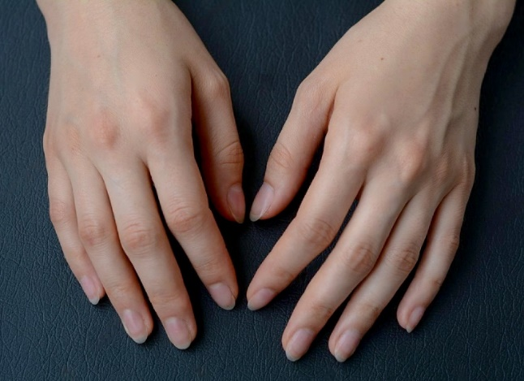
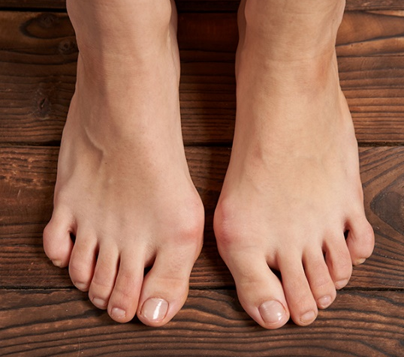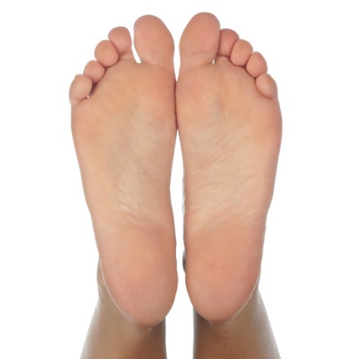

Insert your “BEFORE” picture(s) here.
The picture(s) MUST include BOTH hands for manicures and enhancements;
BOTH feet and soles for pedicures.

AFTER PICTURE(S)
SAMPLE
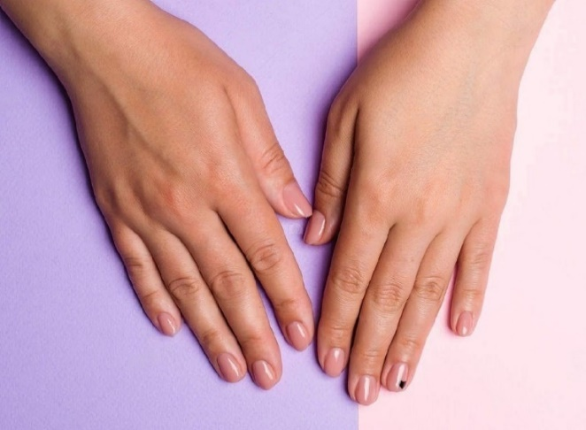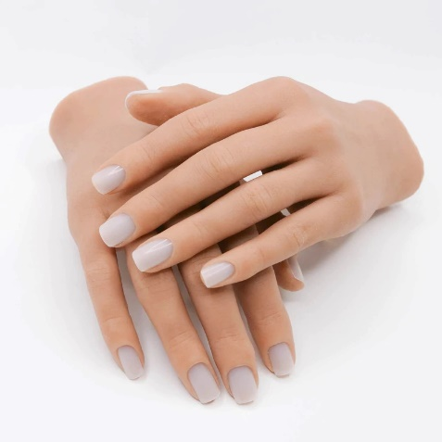
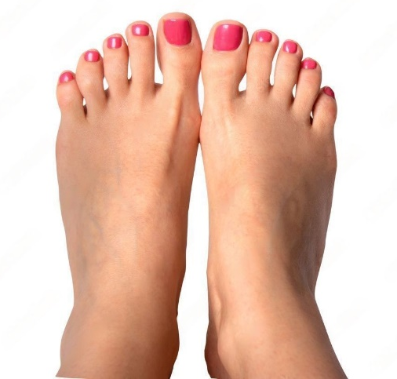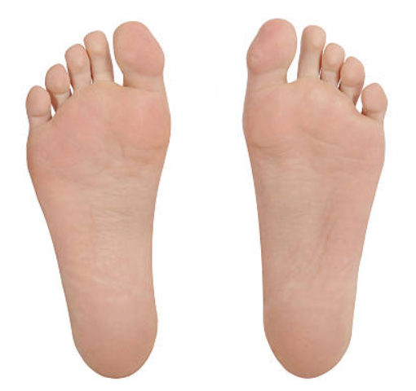

Insert your “AFTER” picture(s) here.
The picture(s) MUST include BOTH hands for manicures and enhancements;
BOTH hands for Nail Trainer OR 2 separate hands
BOTH feet and soles for pedicures.

AFTER PICTURE – SIDE VIEW
SAMPLE
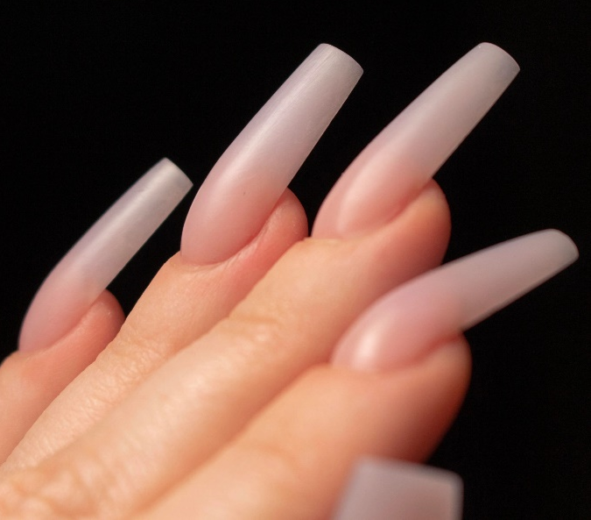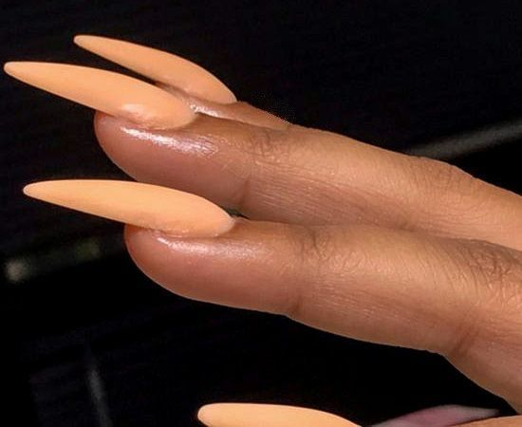
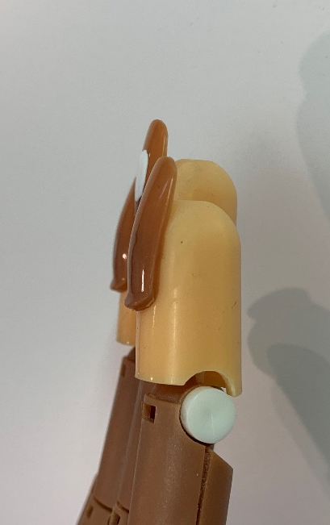

(Insert your “AFTER” picture here.
The pictures MUST show the side view of ENHANCEMENTS only and ALL 10 fingers)

